Fonts & UI Elements
For
-Musical Find -
UI is one of the most important parts from the composition of creating a good game. Our project is a real game in which the main character Ethan, is having a mission to explore four different areas and to collect music plates from which he can listen to parts of one music production.

UI Elements
When the creating of the game started, most of the things we talked about were assets and what exactly will be put in the game, so the final concept was to create physical elements which are part of the game, the player interacts with them and at the same time they are part of the gameplay, and of the UI. Things such as – the music plate
- Music Plate – It is the most important asset because this is the goal of the player, to collect music plates and to listen to the music coming from them. We chose it to be a music plate or vinyl plate because it is part of the history for the exposing of the music in general. And this feature is showing the whole concept of the game as only one asset. When the player is going through a level and see a music plate, it will automatically understand that is important because it is a rare element in the game and its textures are showing it.
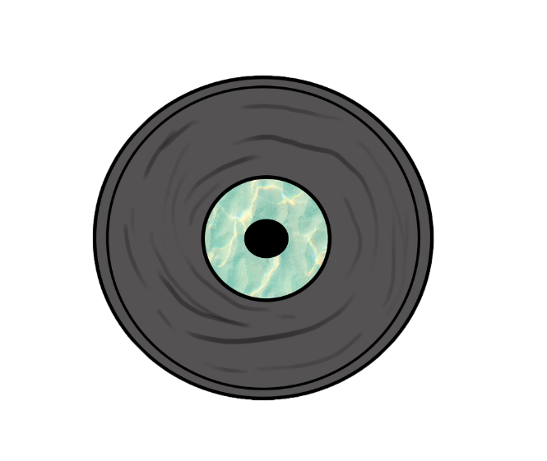
Concepts of the Plate:
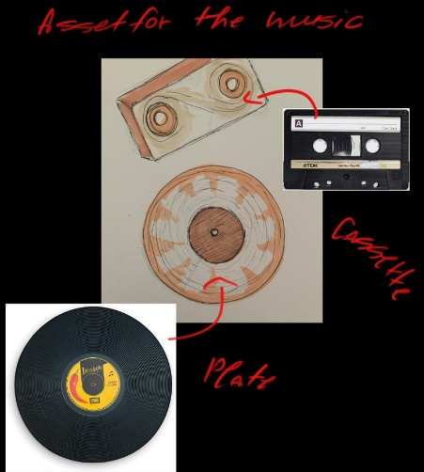
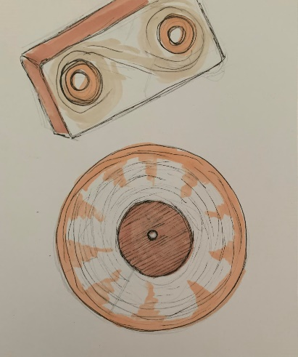

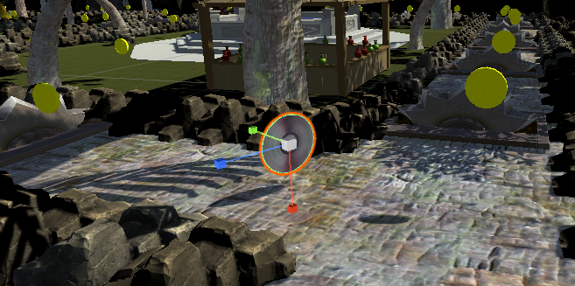
The actual Plate and the 2D image of the plate:

The music plate can be seen on the screen when the player start collecting and next to it a number is displayed to identify how much plates the player collected. It is easy for the player to understand how much Plates has been collected and when it knows the overall number of Music plates for a Level, it can see when he/she collected them all and needs to go to other level.

- Potions and Health Bars – The second UI element are the Health and Stamina including potions which helps them increase by consuming them. The potions are in two different colours, one is ‘’GREEN’’, the other is ‘’RED’’. Health is ‘’RED’’, Stamina is ‘’GREEN’’. This way they can be easily seen and indicated by even the colour-blind people or deaf people. Interacting with them is done by going near the potion, left click to collect (when you have coins enough to buy potions) and then with ‘’Q’’ key is for ‘’RED’’ potion, ‘’E’’ key is for ‘’GREEN’’. This will be displayed on the ‘’How to Play Guide’’.

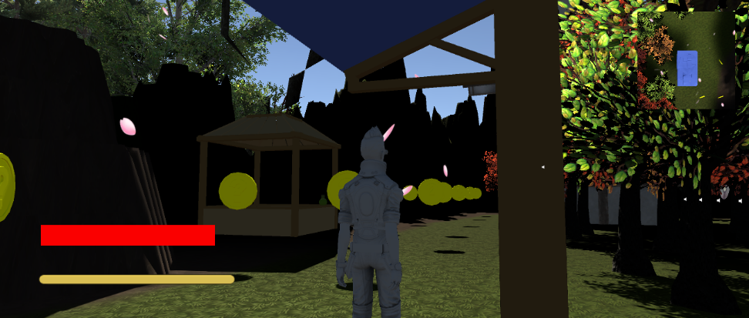
Health Bars Visual:

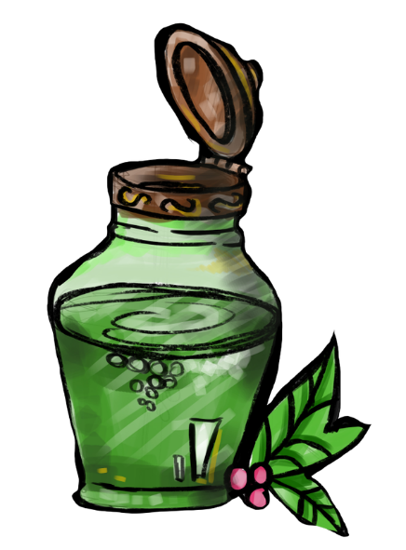
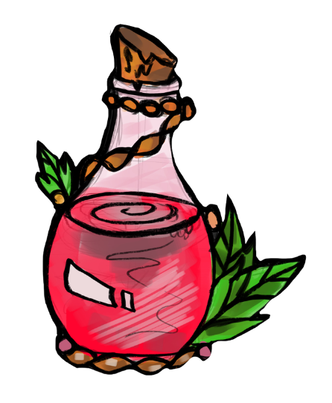
Potions concepts:

- The Potion Shop - For having the Potions, the player needs to buy them from a physical Shop which is asset placed in each level several times because the areas are big, and one shop will make the player to go back each time when it has deficit of potions needed to restore the two bars – Health and Stamina.
The Potion Shop is a physical UI element because it has indication in front of it that is a shop, and the 3D objects (potions) can be seen in it. It is indicated in the ‘’How to play guide’’ how to use the shop. As our game is more about exploration, this 3D physical shop `contributes for the experience to be realistic and made the player to feel our 3D world believable and interact like it is living really in it.

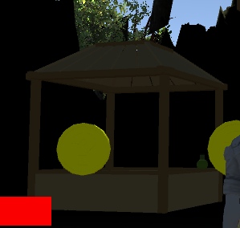
Potion shop in the game:

  - Health Bars - They are two different potions and are connected with the UI because when the player start playing the game, it will be seen on the screen on the left bottom corner two Bars which are indicating how much you have left of your Health or Stamina while playing and going through traps which are supposed to lower them down. For this purpose, the player will learn that it has to go to the shop and buy Potions, to use them. So, for buying the player needs to have something to buy with, that is why we have coins.

- Coins – We have another physical UI which are the COINS. When the player starts the game, the first thing that will be seen are the coins which are everywhere. So, they will be collected and displayed on the sceen as an icon and a number which helps to indicate how much coins the player has. They also create a path which is part of the UI by leading the player to a shop and the end of the level where the teleport is.

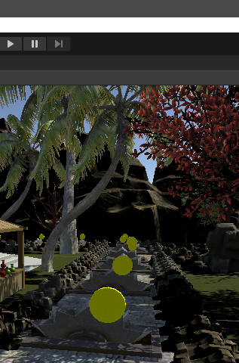
Coins in the game:

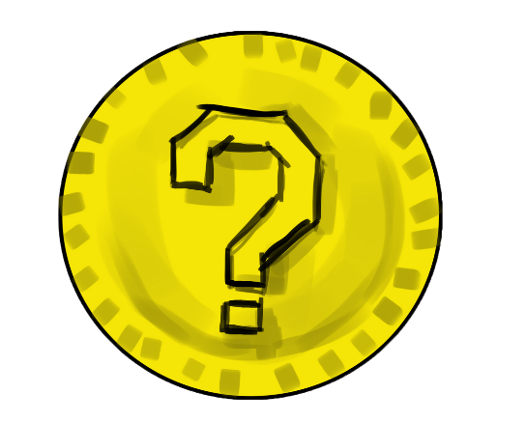
Coin Icon:

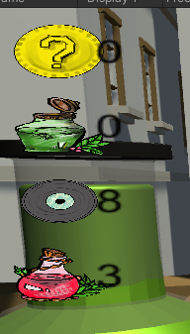
How all the icons look while playing:

- Map – On the top right of the screen while playing, a MAP can be seen, the map helps the player to indicate where he or she is at the right time when playing. The map stays all the time from start to end game.
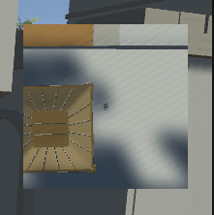
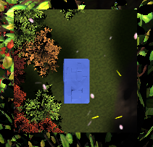
The MAP while playing:

- Main Menu – The main menu is the standard one, not too complex and it has 3 buttons for Play, Exit. This way the player will be able to easy work with it.

- Songs and Sound Effects – For the music plates, there are Sound Effects – parts of each song put for the certain level. When the player collects a music plate, he/she can hear the part of the song and when start to move around again the volume will turn down slowly.

There is a chill background nature music to create better experience while gameplay.

There is a certain sound every time when a coin has been collected, this indicates the collection, and the player will understand that something happened.

- Fonts –

Overall, we created more physical UI elements to teach the player how to play and make the experience more realistic. Our strategy is the player to pay attention to different things in the game while playing.

