Game ideas/ UX ideas
- UX Ideas:
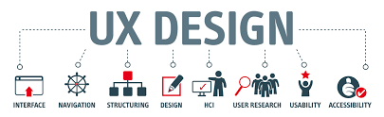

Main menu different design
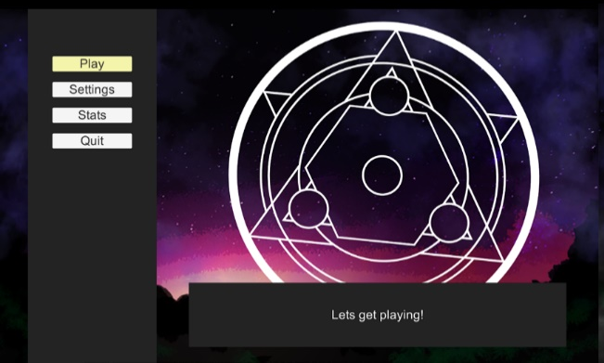
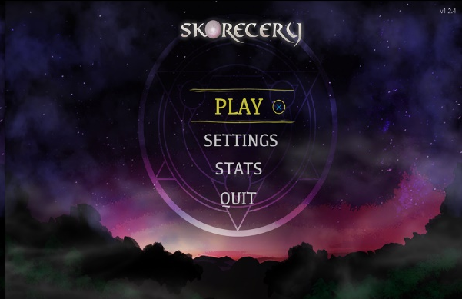

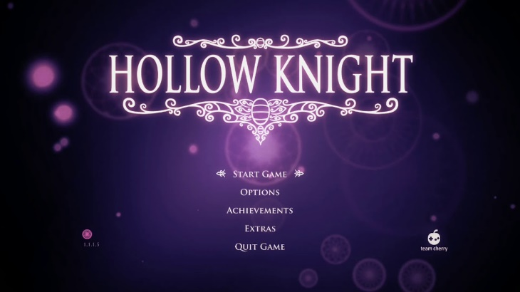
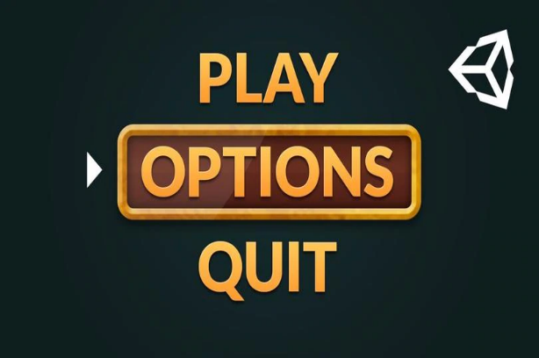

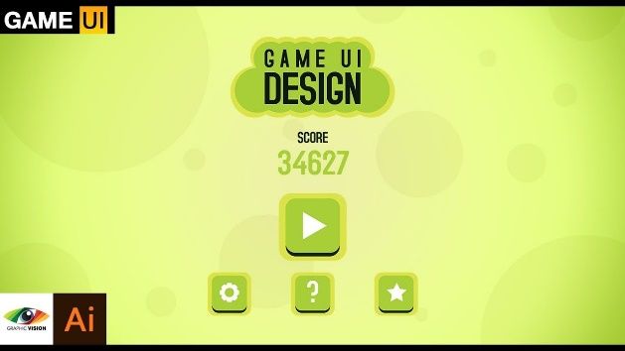

- IDEAS From the Team:
Dilan’s idea:
To make a 2D game which is like Mario, but u can shot and to pass the different jumping puzzles to interact with the environment and the NPC (none playable character) around the whole game main aim to be around the game ideas and to work around to complete different waves of NPC

Nikol’s idea:
Creating 3D simulation experience - a First Person point of view, interacting with objects in an environment such as room. It does not matter if it is a living room, bedroom, bathroom, kitchen or etc. Interacting with each physical object in the room. For example: If you can see a Photo-book on a desk in this room, you can have 3 options: 1. To open the Photo-book and a slide with photos to appear, 2. To take it with you, 3. To leave it where it is without interacting.

Dilan idea and Nikol
https://1drv.ms/u/s!AgkI3lSNLwNBgeVwb7lk3I1DbhFuyw?e=xDDa87idea
3rd Idea: To combine Dilan's and Nikol's idea in one. To create a 2D game based on the real Super Mario 2D game but instead of the official art style and concept art, to create our own unique style. The environment to be 3 to 4 different rooms, it does not mater - living room, kitchen or etc. And instead of interacting with forest things like mushrooms or other objects, to be interacting with wardrobes, chairs, pictures, tables, vase with flowers, couches and more and more.

Erica’s idea:
A music search app that lets you download music straight from the app to your device without getting the link from YouTube and then using a third party mp3 converter to download it to your phone. It is quicker and means you don’t need to jump through adverts that the mp3 converter may have.

New Idea: Dilan and Nikol
The Product for the User:
Creating 3D game with unique UI based on the traditional Super Mario game but instead of 2D it will be 3D. – The product that the User will be interacting with.
- Levels
We will create 5 levels for achievement. With each level the capacity of hardness will increase, and the last level will be with final boss. The levels will be designed, and 3D modelled in Maya and we will use the Unity engine for the overall building of the World for this product

- Weapons

We will design special Shop built inside the Product – Our Game and there the player will choose which suitable weapon for his level to buy.

Hammer
Knife
Sword
Katana
Spear
Baseball bat
Sekira
Battleax
Saif

- The Character
We will decide whether to refence a character or to create it. The view will be 3rd Person.

